**LAB # 1**

**Introduction to GitHub**

**OBJECTIVE**

**Introduction to GitHub by creating Git repository and cloning its configuration to eclipse project.**

**Lab Task:**

1. **Create account on GitHub**

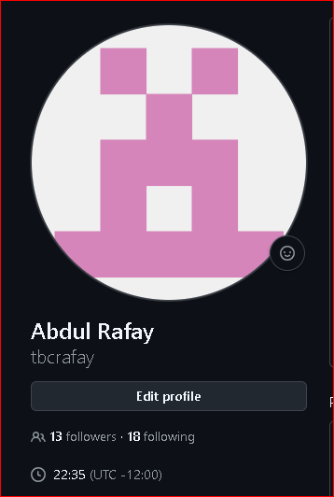

1. **Upload any of your Java Project files and perform commit, push, pull and merge operations.**

**Created branch, upload file, commit log, display file**

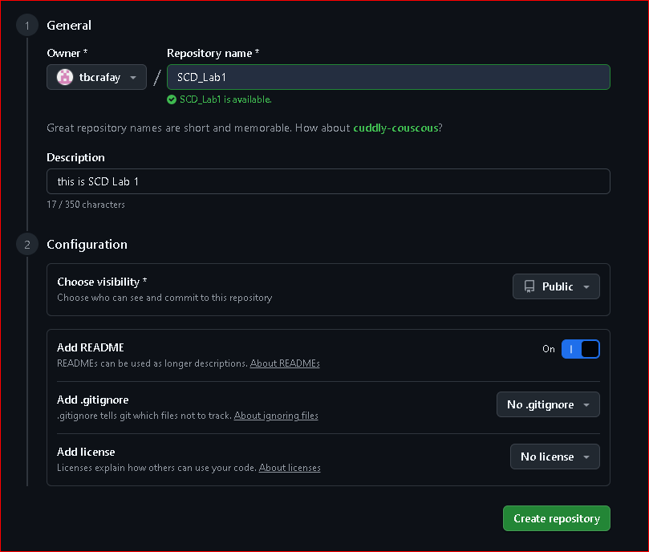

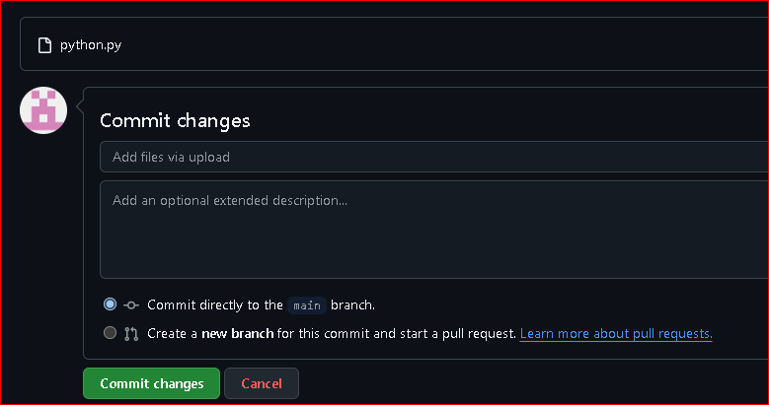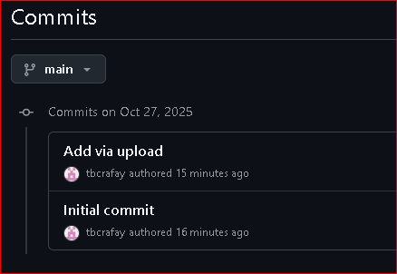

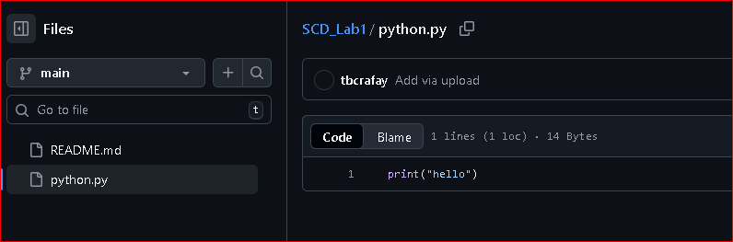

**Create branch V2, update python.py file, open pull req, successful merge**

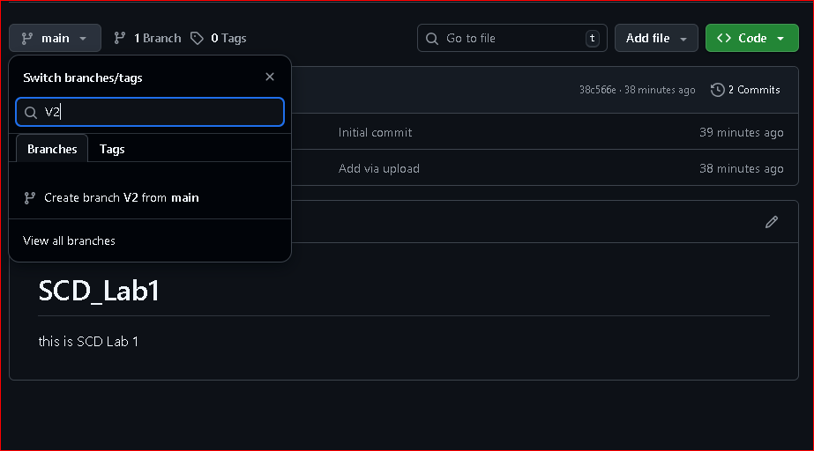

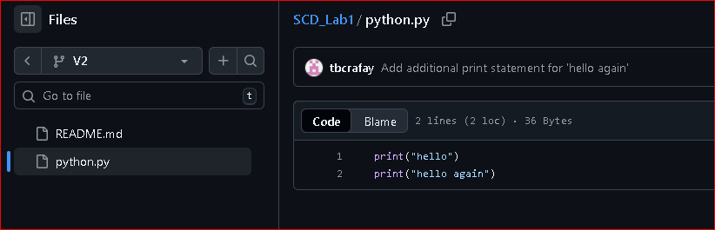

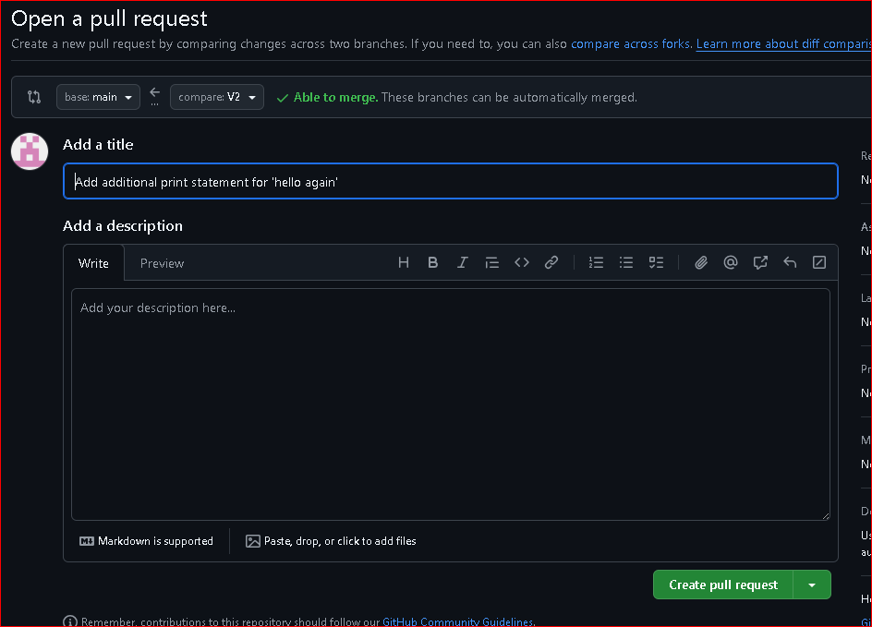

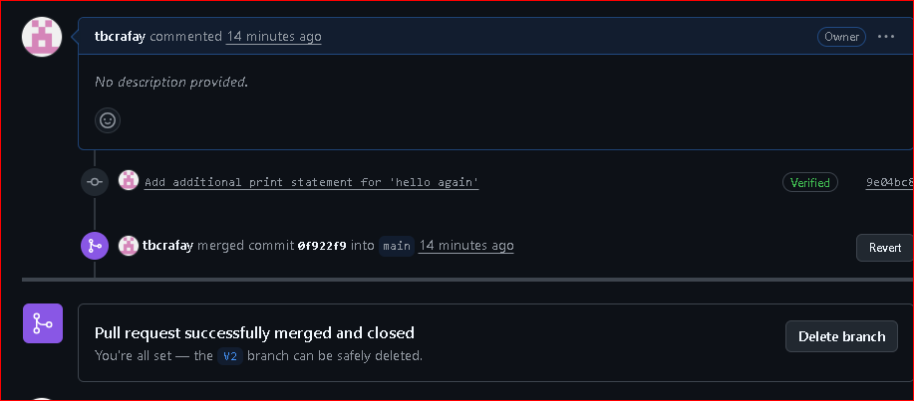

**Display the updated file python.py in main branch after merge and pull.**

